**BLIS-KENYA V2.5**

A joint initiative of C4G @ Georgia Tech, the CDC,

@iLabAfrica - Strathmore University, Association of Public

Health Laboratories (APHL) and participating countries

**Standard Operating Procedures (SOP)**

Contents

Sample Collection 2

Receive Request 2

Accepting a Specimen 3

Rejecting a Specimen 3

Testing 4

Starting a Test 4

Entering Test Results 4

Editing Test Results 5

Results Verification 6

Full Haemogram Test on celltac F machine 7

Culture and sensitivity test 8

# Sample Collection

## Receive Request

If you don’t see the request among the listed, SEARCH for the patient using the PATIENT NUMBER or the PATIENT NAME as captured below. Press ‘Enter’ after giving the search value

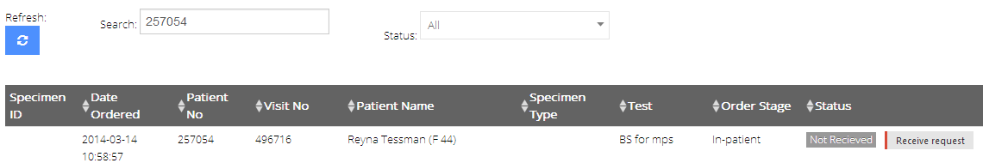

Receive the request using the ‘**Receive request’** button on the far right of the row to get the following display

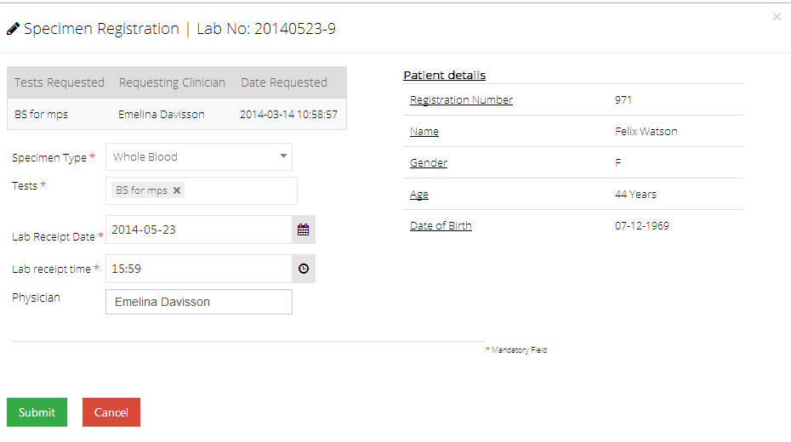

After submitting the details using ‘Submit’ button, the following will appear to confirm successful submission



## Accepting a Specimen

Once you have received the request, you’ll need to check the specimen for acceptance.



If acceptable, press the ‘Accept’ button to be directed to the following page.



You’ll get the specimen number in the format: PAR-0001. PAR identifies the laboratory section the specimen shall be worked on and 0001 represent the actual specimen identifier. Label the specimen with that specimen number provided. Sort the specimens ready for dispatch to the sections.

## Rejecting a Specimen

A specimen may fall short of the standards required for a test, might be unlabeled, insufficient or due to other reasons. If so, search for the specimen and on the corresponding row of the specimen, press the ‘Reject’ button.



Fill in the form appropriately and submit it using the ‘submit’ button

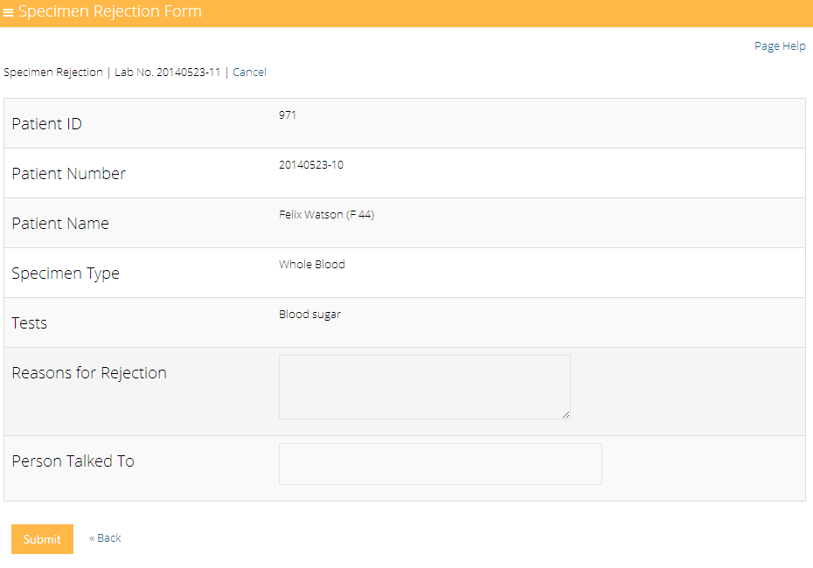

You have successfully rejected the specimen as captured below.



# Testing

## Starting a Test

Search for the patient, test or specimen OR filter using the dropdown under ‘Status’ select box for ‘Pending.



Click on the ‘Start test’ button

The status will change to ‘Started’ as captured



**Proceed to perform the test**

## Entering Test Results

Once through with the tests and results are out, Search the patient or specimen. Go to the corresponding row and click on ‘Enter results’ A pop-up form will be provided to be filled in appropriately.

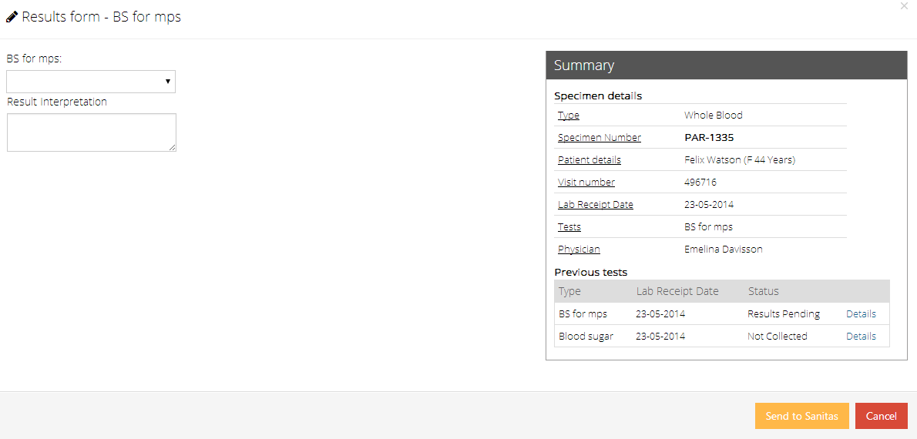

Once done, submit the results using the ‘Submit’ button to get the following confirmation



## Editing Test Results

Search for the patient, test or specimen OR simply filter using the dropdown under ‘Status’ select box for ‘Tested’.

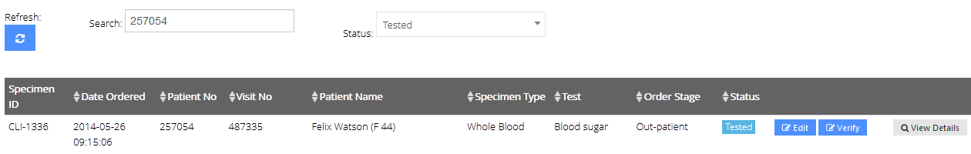

On the corresponding row, click on ‘Edit’ to open a pop-up form with pre-filled data

Update the results as appropriate and save the changes by using the ‘submit’ button.

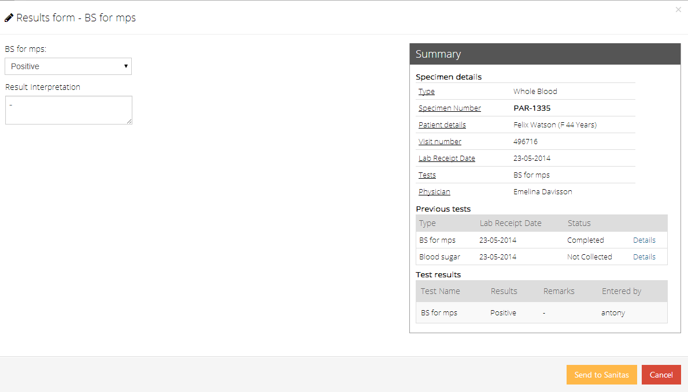

## Results Verification

Specific heads of lab sections are assigned results verification privileges.



To verify results, press the ‘Verify’ button and the following pop-up will be displayed

Press the ‘Verify result’ button to verify

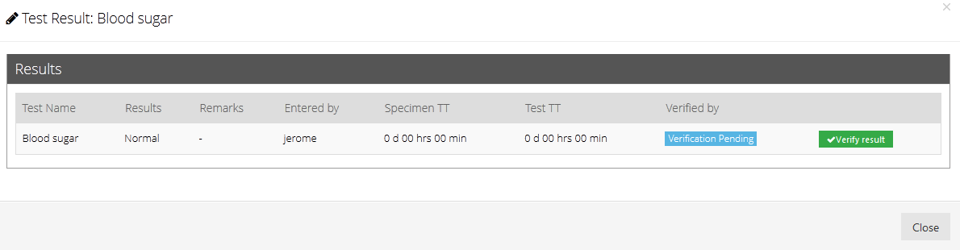

The name of the one who has verified will be displayed under ‘Verified by’

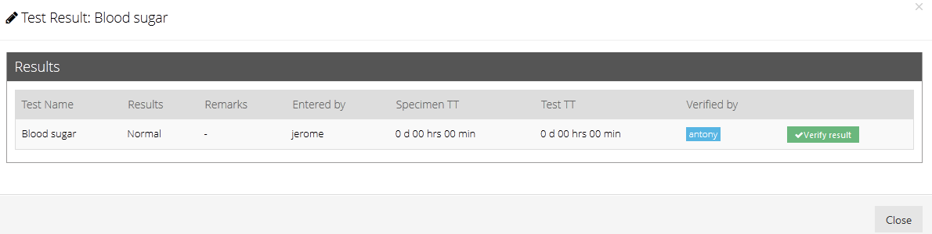

Close to see the verified status

C:\Users\strath\Desktop\BLIS-Kenya Documentation\img\test\15.png

## Full Haemogram Test on celltac F machine

Search for the visit number or (patient number or patient name)

Click **start test** an perform the test

On the celltac F machine; press **Print Results** button to send the results from the Celltac F machine to the computer

On the computer;**C:\Users\strath\Documents\BLIS-Docs\BLIS-Kenya Documentation\img\test\FullHae2.png**

Click **Enter results** to get the results entry pop-up

To enter results sent from the celltac F machine, Click **Read results** button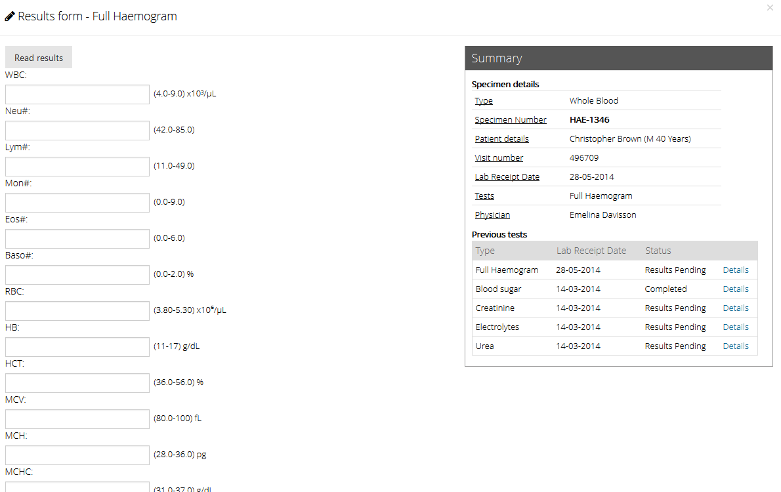

The results will be loaded as shown

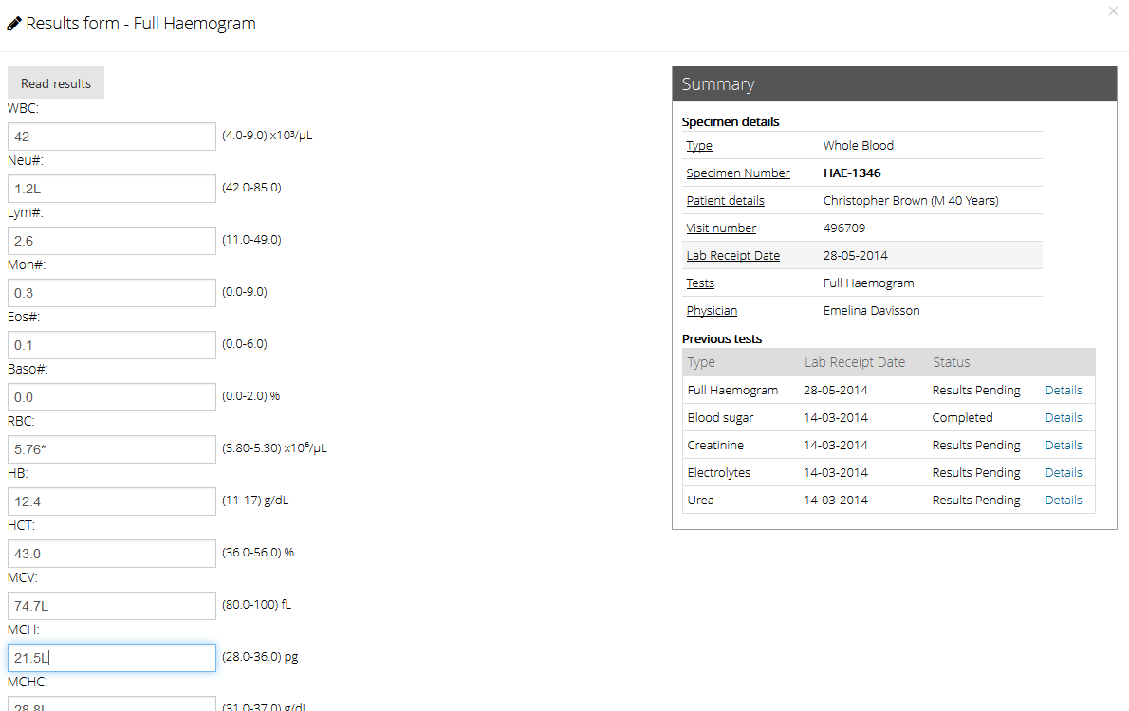

Scroll to the bottom of the pop-up and Click **Send to Sanitas** button to submit the results

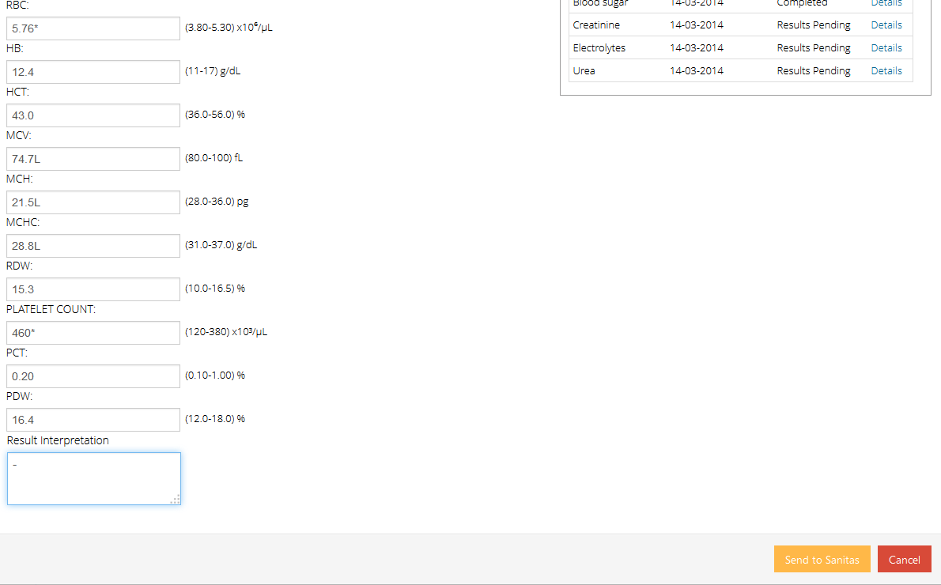

## Culture and sensitivity test

### Lab configuration set up by the system administrator

On the side menu Click **Test catalog** and under it Click **Test Types**

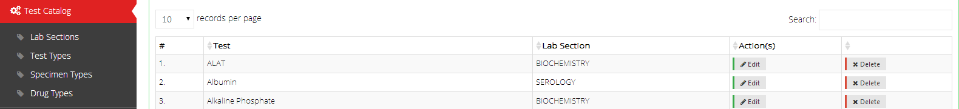

Search for the test name (in this case; **HVS for culture and sensitivity)** by typing all or part of it and press **Enter**



Click **Edit** and scroll down to **Show culture worksheet?** Option

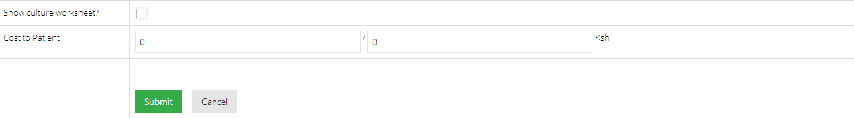

Check the **Show culture worksheet?** Box to load the drugs and check appropriately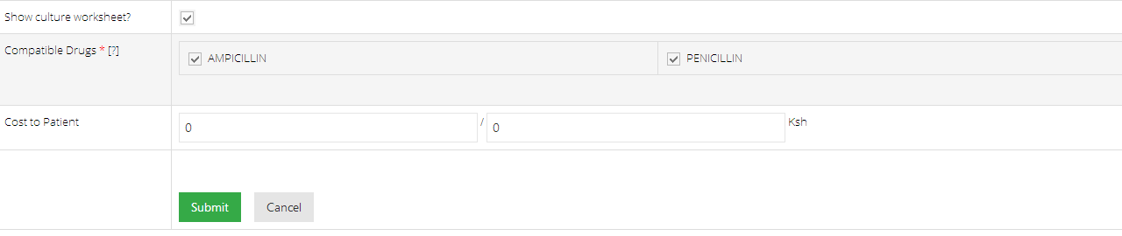

Click submit to save

### Lab Technician’s guide

Search for the visit number or (patient number, patient name or test)

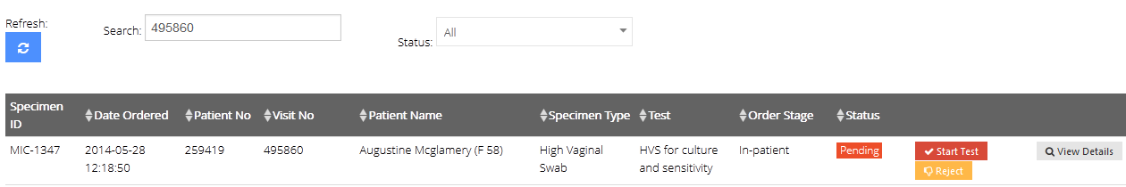

Click **start test** and start performing the test



Click **Enter Results** to open the results entry form

For the Observations and work-up; add the observation and click **save** on the right of the entry to save it

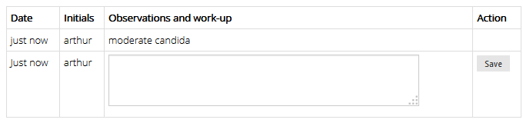

Enter other values available at the time and (scroll down to see) click **Send to Sanitas** to save the whole form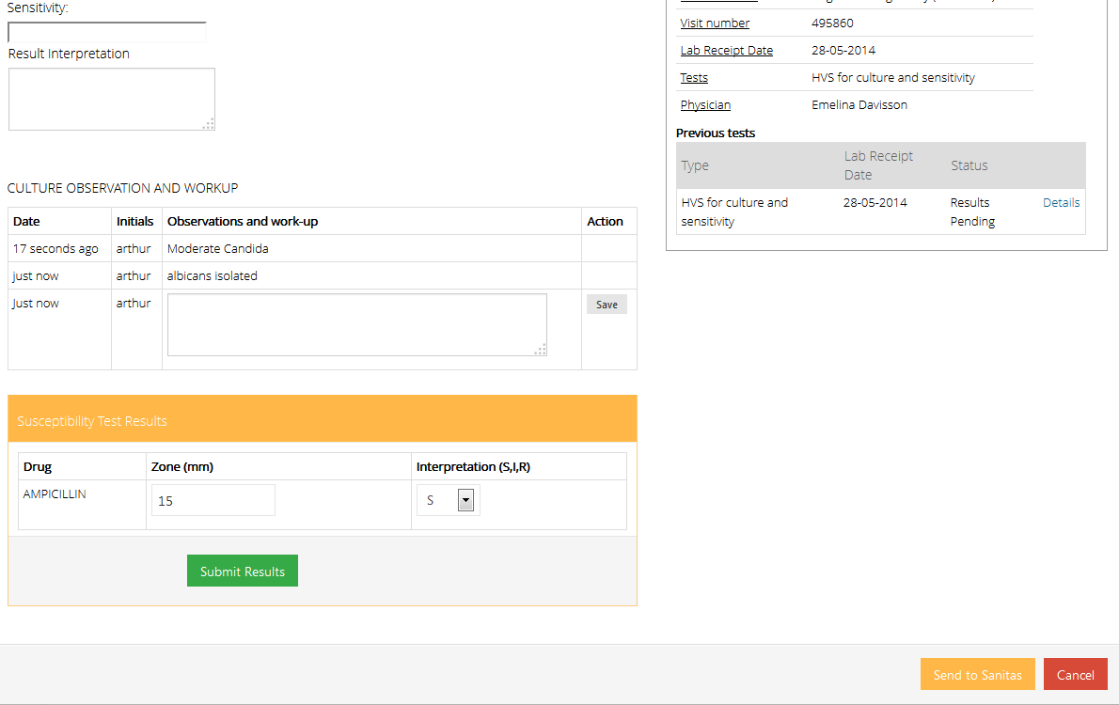

After which you will see the status of **tested** for that entry



To enter additional observations and values click **Edit,** and after changing and/or entering new values, click **Send to Sanitas** to save